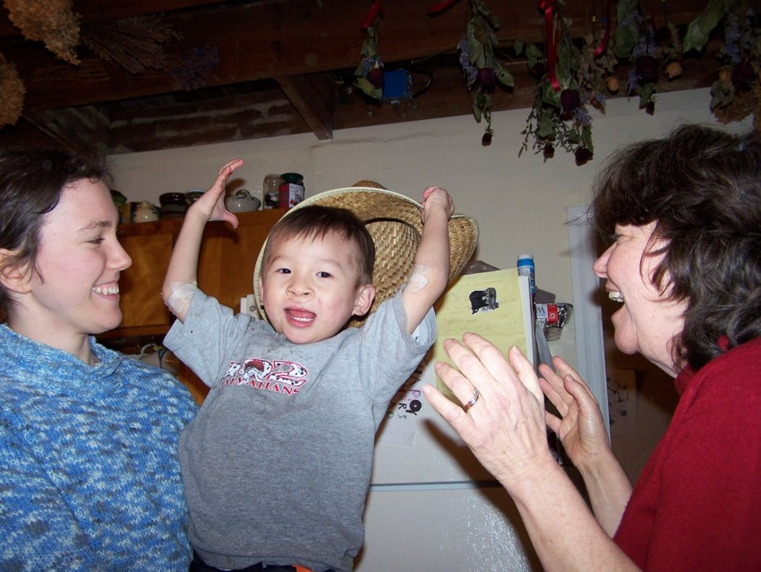
Christmas 2008

Dear friends,

Merry Christmas and a Happy New Year! We pray your new year will be full of blessing, overflowing with peace beyond understanding.

The Styer family has had more than its share of blessing this past year. With lots of encouragement from friends who adopted from China, we applied to adopt. This past January 15, we adopted a son; the Chinese government matched us with a three year old boy with cleft palate who is very intelligent, very inquisitive, very active, and very affectionate (in a rough and tumble way). We named him David Chuan Jian Styer. He is bonding well with our whole family, and is a delight to all four of our other children. The cleft palate surgery at Easter went well, and the four-day-a-week speech therapy is finally beginning to show its value. David’s comprehension of English was amazing within two weeks, and at his March three month evaluation, his English comprehension was at a three year old level. But I never realized how difficult it is to speak, and how many muscles must be coordinated to talk.

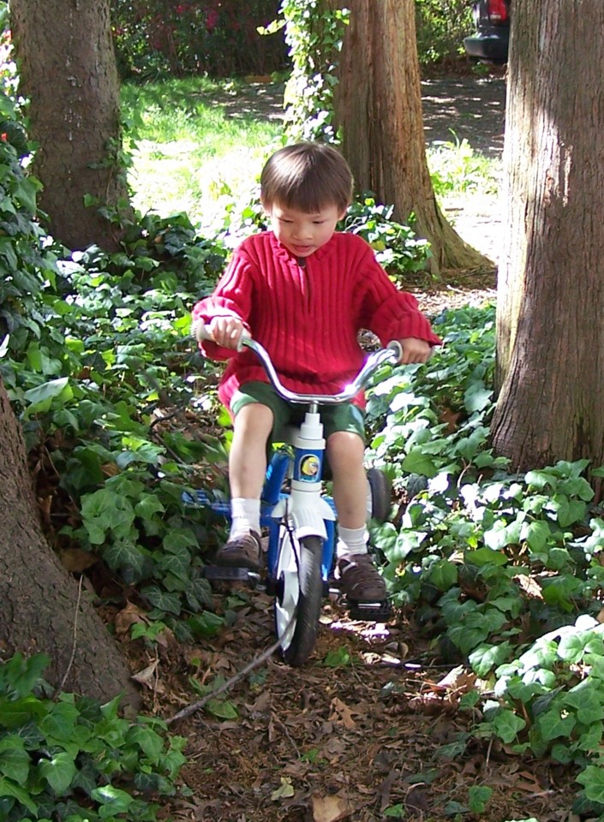
David loves Legos and micromachines, so maybe he will be an engineer. He loves sword fighting with his brothers (often he is Peter Pan, sometimes a pirate or knight in shining armor). Joey teaches him to climb high in trees and to jump down the stairs, but so far David has not gotten hurt. It is comical to see David getting his hugs and kisses from Joey and Andy. He goes up to them for his hug and kiss, then when they bend over, he runs away begging to be chased and caught.

Meantime, Amy is doing well as a junior biochemistry major at University of Delaware. Amy has a dream of finding the cure for malaria or leishmania or sleeping sickness, and so wanted to visit Africa. She planned to go to Kenya in January but the unrest following the elections led to her canceling that trip, so she ended up going for a short time at the end of the summer.

Melanie started as an agricultural sciences major at University of Delaware this fall, and she is doing very well (except for some unbelievable roommate situations, ask if you are ready for a long story.) She has switched majors a few times before and since entering Delaware, but her latest thoughts are to get a PhD in ruminant nutrition. She loves the hands-on curriculum, such as sticking her arm up a pregnant dairy cow.

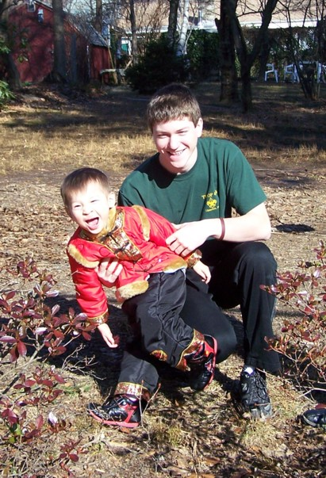
Joey decided he wanted to taste the public school environment, so he is taking a math course at the high school. Then he has Spanish at the private Christian school down the street where Peggy teaches English, chemistry and sociology at Villanova, and physics with a group of homeschoolers. So he is still 20% homeschooling except he is never home! He is cultivating many friends and thus has many parties, and still enjoys soccer and some Boy Scout activities.

Andy’s obsession is High School Musical so he was thrilled last summer when the Upper Darby Summer Stage program did that play; he was a brainiac. This summer the UD Summer Stage play was Peter Pan (he was a pirate) and coincidentally the little homeschool theatre group also did Peter Pan (he was the lost boy Slightly Soiled.) He will play Doctor Caius in Merry Wives of Windsor this winter.
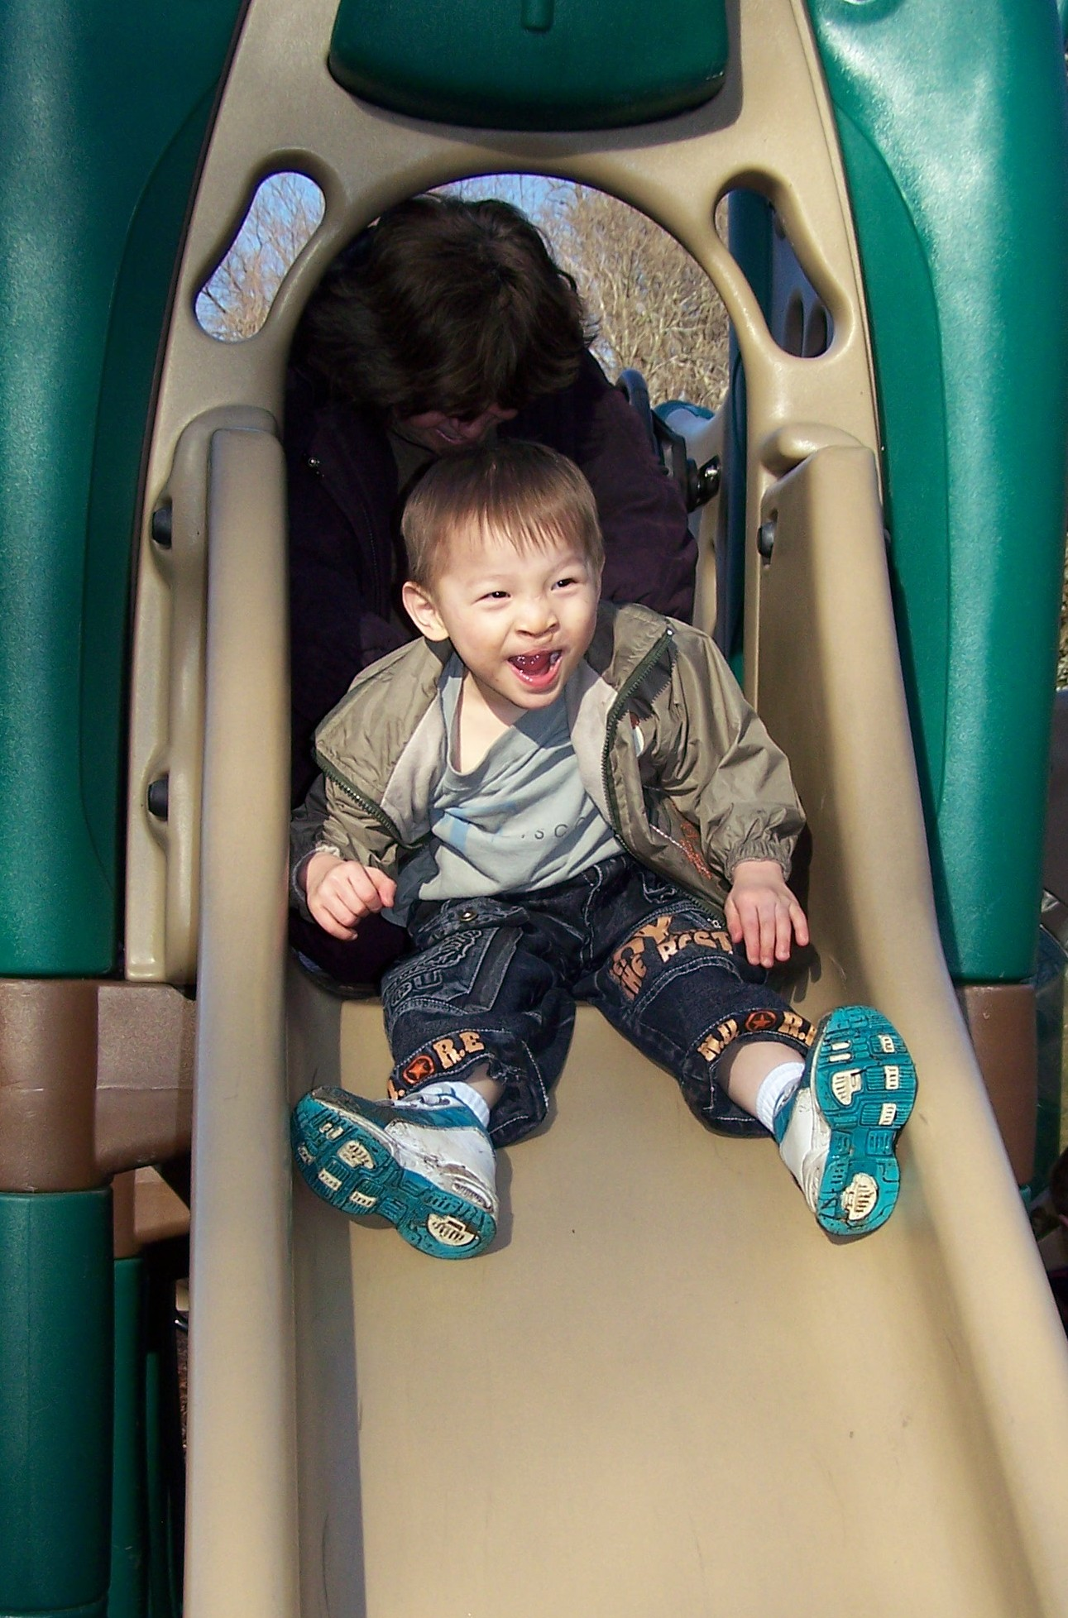
Peggy is busy with David (driving him to speech therapy) but is still teaching one 6-7 grade English course at Cornerstone. Bob is still busy at Villanova and hoping the economic downturn does not affect private college enrollments. Bob had a conference in Wisconsin, so we visited the Wightman’s in Minnesota and had a wonderful time with them. Also this summer, my brothers all got together to celebrate my dad’s 80th birthday. He has diabetes and Parkinson’s, but is doing well considering.

We pray that God will bless you as we have been blessed this year.

Love, Bob and Peggy, Amy, Melanie, Joey, Andy, and David Styer
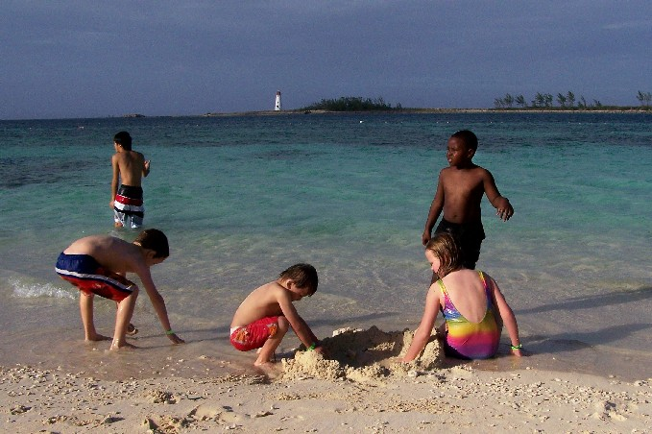
PS: It is now after Christmas, and our excuse is that Bob’s mother has planned for years to take all her grandchildren on a cruise, so we spent Christmas week on a cruise from Jacksonville to Key West to the Bahamas. We swam in the ocean on Christmas day!

