Curcio 1
Alexa Curcio
Dr. Frey & Dr. Volpert
Math Seminar
3 May 2010
Height Distributions & Taboos
Would inserting a taboo on height that restricts women from marrying shorter men alter the average height of the population over one hundred generations? After some research, and through certain simulations, I have attempted to answer this question for several different taboos. First, I looked into some facts about the distribution of height all around the world, and more specifically in the United States, which I used for my simulation. I also researched certain cultures that practice some of these taboos and tried to make a correlation between these taboos and height. Next, through several assumptions, including using an offspring height formula, I was able to create a stable population that would show any differences in height after a taboo was placed on a population. Finally, I realized the faults within comparing my simulation to a real life scenario.
The height of a population is normally distributed, following the shape of a bell curve. This means that the height distribution is concentrated at the center and decreases on both sides. The curve of the graph is symmetric and the deviations on each side of the mean are equally spaced (Simon). In most populations around the world, and in the United States, males are generally taller than females. In the United States, males over the age of 20 of all races or ethnicities have an average height of about 69.3 inches, or about 5 feet 9 inches. The average height for females is 63.8 inches, or about 5 feet 4 inches. In this survey, the standard error for
Curcio 2
males is 0.17 inches and as little as 0.01 inches for females. The standard deviation for both males and females is 2.8 inches (McDowell).
When examining the question of placing a taboo on height, I decided to look for a correlation between height distributions and marriages that already abide by such a taboo. I found in certain arranged marriages, the family of the bride looks for a groom that is about a few inches taller than the bride. While it was not prohibited or discouraged of the female to marry a shorter male, it was simply encouraged for the female to marry a taller male. In order to find an average height for such arranged marriages, I researched where certain cultures that practice arranged marriages reside. These countries include India, Pakistan, Iran and Iraq (Kettani). I found the average height in Pakistan for males is 5 foot 5 inches and 5 foot 4 inches for females. The average height in India is 5 foot 7 inches for males and 5 foot 1 inches for females. In Iran, males are 5 foot 8 inches and females are 5 foot 3 inches. Finally in Iraq, males are 5 foot 5 inches and females are 5 foot 1 inches (Height Chart of Men and Women in Different Countries). The heights within each population varied, and there was no specific trend among all of these countries with regards to height.
After further examination, it became clear that this research was far from bullet proof. For one, there was no specific law prohibiting a tall female from marrying a shorter man. Also, arranged marriages are part of a culture, and not something practiced within the entire country. Therefore, when calculating the average height of a country, taking into account that some marriages are arranged and some are not makes things a little fuzzy. Even more, a culture that practices arranged marriages can exist throughout various parts of the world. The Muslim religion, for instance, practices arranged marriages, but Muslims exist all over the world, more
Curcio 3
specifically in Asia and Africa (Kettani). These two areas are extremely different in height and environment. This brings up the last point, there are many other factors, including environment, nutrition, genetics, and medical history that alter the height of a human being.
After sufficient research, it became clear that I needed to simulate my own height experiment. Before placing a taboo on the population, I needed to create a stable population while making several assumptions. First, I needed to have a set amount of males and females within this population. In order to create a stable population, I needed to have each couple produce a male child and female child, so as to keep the new generation at the same number of males and females as the old generation. I created a population of 100 males and 100 females with mean and standard deviation the same as that of the United States, 64 inches for females, 69 inches for males, and 2.8 inches for the standard deviation. Next, I needed to assign a height to the offspring. This is where things became a bit complicated and I began researching and throwing out ideas of my own for simulating the height.
Calculating the offspring height, with only the heights of the mother and father available, is something I researched thoroughly, but found no concise answer to. Several pediatricians' answers included a formula that consisted of averaging the male and female height, and either adding 2.5 inches if the child were male or subtracting 2.5 inches if the child were female (Sokal-Gutierrez). This is known as the mid-parental height calculation and is based on genetics. This has been proven accurate to predict the child’s adult height to within two inches (Patt). I decided to use this formula when creating a stable population. This would create males that were generally taller and females that were generally shorter. Next, I needed to find a standard deviation for the children’s height. Assuming that the mother and father height are dependent, I
Curcio 4
calculated the variance of the children’s height by using the variances of the mother and father. This left me with V[(F+M)/2] or , when factoring out the constant and squaring it, ¼ * [V(F) + V(M)] = ¼ (8+8) = 4. In order for this to create a stable population, however, some variability must be added to the calculation. Another formula I played around with had the height of the offspring depending more on the gender of their parent, by using 1/3 of the mother height plus 2/3 of the father height for a son and 1/3 of the father height plus 2/3 of the mother height for a daughter. This also created a stable population with constant means.
In my actual R code, I used a normal random number generator to generate 100 fathers with mean height 69 and standard deviation of 2.8 and 100 mothers with mean height 64 and standard deviation of 2.8. Next, I created matrices containing 100 daughters and 100 sons. Next, I introduced a for loop to create multiple generations where I generated daughters and sons very similarly. For sons, I took a sample of the fathers and a sample of the mothers, increased the count by 1, and formulated a son by using a similar normal random number generator with the mean being the father and mother height added together then divided by 2 plus 2.5 inches. For daughters, I did the same, but subtracted 2.5 inches. Within this loop, I needed to change the generations so I could make the sons become fathers and the daughters become mothers. To do this, I simply set the father equal to the son and the mother equal to the daughter. I printed out the mean heights for each generation. Finally, I compared the mean heights of the mother and father in a histogram. On the following page is my final R code for creating a stable population:

Curcio 5
n = 100 # number of observations
gens = 100 # number of generations
father = rnorm(n, 69, 2.8) # Males are normal with mean 69 and sd 2.8
mother = rnorm(n, 64, 2.8 ) # Females are normal with mean 64 and sd 2.8
son<-double(n)
daughter<-double(n)

for(generation in 1:gens)
{
# Generating the sons
ct = 0
while (ct <100)
{
father1 = sample(father,1)
mother1 = sample(mother,1)
ct = ct+1
son[ct] = rnorm(1,(father1+mother1)/2+2.5,2)
}

# Generating the daughters
ct = 0
while (ct <100)
{
father1 = sample(father,1)
mother1 = sample(mother,1)
ct = ct+1
daughter[ct] = rnorm(1,(father1+mother1)/2-2.5,2)
}

# Changing generations
father = son
mother = daughter
print(c(generation,mean(father),mean(mother))) #Printing out mean heights.
}

par(mfrow=c(2,1))
breakpts<-55:80
hist(mother,breaks=breakpts, freq=FALSE)

After creating a stable population, I was able to insert a taboo. By simply placing a while loop in my code after the original while loop, while the father height was greater than the mother height, I could generate this new population. After simulating this process several times, I found
Curcio 6
that there was little to no effect on the height of the entire population. Sometimes, it created a slightly taller population and sometimes it created a slightly shorter population, but there was no apparent difference. I attempted the taboo for more generations, but still found the same result, sometimes a shorter population and sometimes a taller population. Next, I inserted a larger taboo, allowing females to only marry men that were 6 inches taller. This produced the same result again and the same result for more generations. I changed the difference to 10 inches and then 12 inches, but the population never increased or decreased overall.
For the first part of my presentation, I found that placing a restriction on height did not affect the height of the entire population over time. The means of both males and females neither became closer together nor spread farther apart. The difference in male and female height remained constant throughout all of these simulations. This taboo had little effect for several reasons. First, the means of females and males differ by 6 inches with a standard deviation of only 2.8 inches. This means that the odds of a female meeting a male that is shorter than she is are very little. It would require both male and female to be over 2 times the standard deviation outside of their mean height.
It must also be concluded that this simulation cannot be used to accurately model a real life scenario. Before the taboo is even placed, we run into several problems. One of these problems is that height is not completely dependent on mother and father height, but that other factors, as mentioned above, contribute to the height of a human being. Also, calculating the offspring height is a mere assumption and, while it has been proven to accurately predict the height of a child to within a few inches, it is not 100 percent accurate. This simulation also assumed that each couple had two children, in order to create a stable population. In real life, a
Curcio 7
couple may choose to have no children, stopping this generation from ever producing again, or having 10 children, creating a lineage of very short, average, or very tall people. Each of these could affect the height of the entire population. When inserting a taboo, we face even more problems. We still have marriages that will exist that do not abide by these restrictions, especially for immigrants that are already married that enter the country. Immigrants that are not married will alter the height of the population as well. Since males are generally taller than females, such a restriction would not alter the height of the entire population significantly.
For the second part of my presentation, I began addressing some questions from students from last time. One of these included placing a cap on the height. I decided to place a cap on male height, making sure males were not taller than 7 feet. I simply inserted another while statement in the R code with the taboo, making sure males were shorter than 84 inches. I found that my results here did not differ from the results of simply inserting the taboo. The reason for this appeared to be that my R code somewhat had a “cap” on height already built into it. My code already excluded such large outliers. Heights were generated normally with a set mean and standard deviation. Because of this, there was little room for outliers, such as males being 7 feet tall. Placing a cap on height, therefore, simply had no effect because the code already took this into consideration when using a small standard deviation and normal random number generator.
Next, in order to demonstrate the normality of the height distribution, I displayed the histogram of my stable population with the normal curve. For females, I used a normal curve with mean 64 and standard deviation 2.8, and for males I used the mean 69. While the histograms did not match completely, it was clear that they followed a normal distribution, with

Curcio 8
a similar bell curve and peak at the mean and deviating about 5 inches to the left and right. The comparison can be seen below:
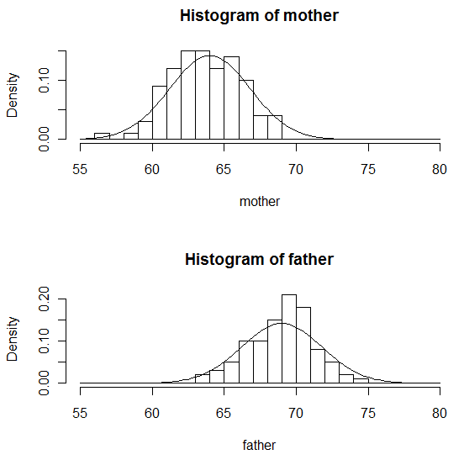
Comparison to Normal Curve

Several questions asked if inserting birth defects would affect the simulation, and if the simulation allows for a child to be taller than his parents. Again, my situation allows for variability, but the odds of a child having a birth defect and reproducing are quite small and would have no effect on such a large model. The offspring calculation I chose does in fact allow a son to be taller than both of his parents since it averages his parent’s heights and adds 2.5 inches to this average. It also has some built in noise from the normal random number generator. It is less likely for a daughter to be taller than her parents because the calculation subtracts 2.5 inches from the averaged height of the parents. Through some research I found the probability of a son being taller than his father given that his father’s height is above average is 0.718, or

Curcio 9
about 71%. The probability that the son is taller than his father regardless of the height of his father is 0.5 or 50% (Stapleton 142).
I decided to insert my entire code into another for loop and use more runs to see where the height of the population usually ended up. After inserting my entire code into another for loop, I stored the mean of each generation at the end of each generation and then printed all of these in a histogram at the end of the code to show the variability in the results. I used this loop for the code after the taboo was inserted. After the taboo was added, the mean heights of males and females varied in both directions. It usually tended to stay the same or decrease in height. Adding in more runs showed how much variability there was for this simulation. It would have been more beneficial had the simulation produced consistent results, always taller or always shorter. The difference between the mother and father height remained relatively constant, ranging from 4.5-5.5 inches. This can be seen in the graph below:
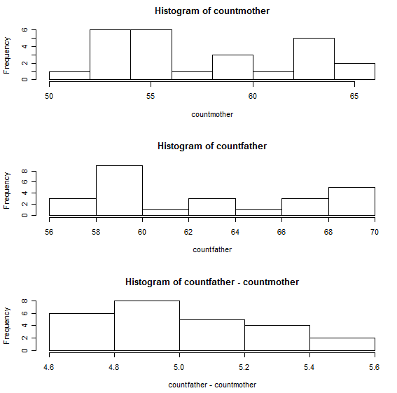
More runs with taboo

Curcio 10
I then decided to compare the means and standard deviations of males and females before and after the taboo was added as well as the difference in height between males and females over time. In R, I stored the value of means and standard deviations in separate vectors outside of the for loop. Inside the loop, I stored the generation by generation values. At the end of the loop, I plotted a vector against the vector 1:gens. Before the taboo was added, it was clear that the height of the population tended to increase for both male and female heights in a similar pattern, keeping the difference between males and females the same, at about 5 inches. Standard deviations fluctuated to within 1 inch above and 1 inch below 2.8 inches. After the taboo was inserted, the mean height of men and women fluctuated between their mean and about 5 inches below their mean, the difference between males and females remained the same, and the standard deviation again fluctuated between the same ranges. The comparisons are shown on the next page, with men shown on the top of the graph and women on the bottom part:

Curcio 11
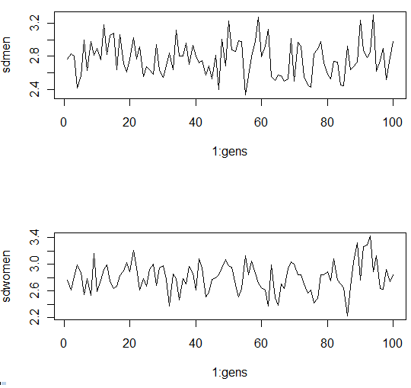
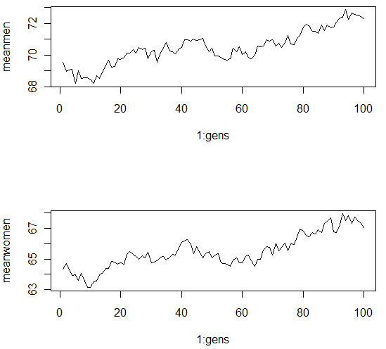
Means over time before taboo Standard deviations over time before taboo

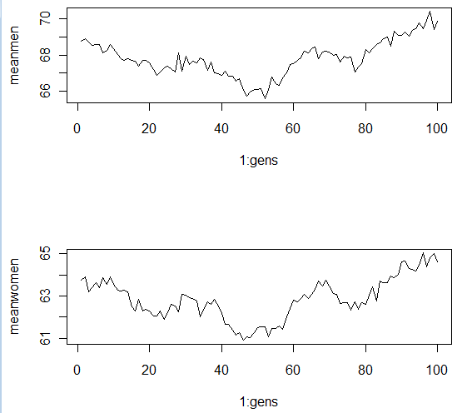
Means over time after taboo

Curcio 12
Next, I decided to reverse the taboo to see if this has a different effect on the height of the population. In reversing the taboo, women were only allowed to marry men that were shorter than they were. In R, I simply made the while loop so that women were taller than men. The height of the population tended to either increase by about 5 inches or decrease by 5 inches. I found that the height of the ending population depended on the height of the first generation. If the first population was a shorter than average population, it would produce an even shorter population over so many generations, and a taller one if it was a taller than average population. This was the only assumption I could come up with. I then inserted more runs for this taboo. I found that the height of both males and females tended to decrease most of the time, but sometimes it just stayed the same. The difference between male and female height remained constant at about 5 inches. Below is the graph of the reversed taboo with more runs:
Reverse taboo with more runs
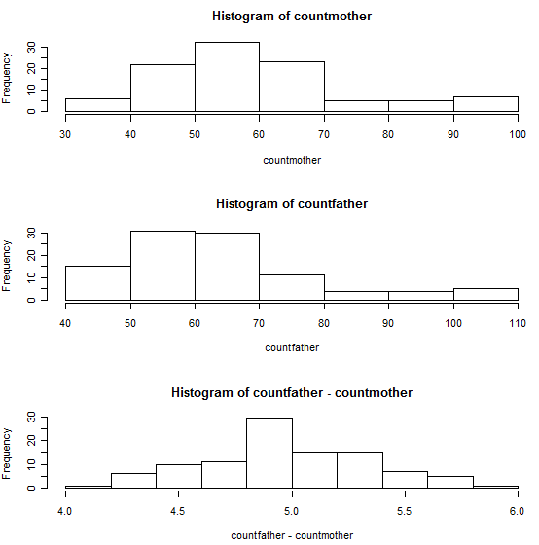

Curcio 13
In the last stages of my simulations, I created a population with males and females with the same mean. I found then even if they started with the same mean, using the same offspring formula I had originally been using altered the population so that males ended up averaging about 6 inches taller than females. Since the formula called for adding 2.5 inches for sons and subtracting 2.5 inches for daughters, it created a difference of about 6 inches between males and females. After seeing this difference, it became clear that the standard deviation and offspring calculation were altering the results of each simulation.
I decided to alter this formula further, and simply average the heights of the mother and father for both sons and daughters. Here, I was given a population of males and females of the same height. I then decided to insert my original taboo into the code. After inserting the taboo, I found that if the height went up for one gender it went up for the other, and if it went down for one gender, it went down for the other. I could not conclude much from this so I inserted more runs. Inserting more runs showed that the height of the population increased. It mostly increased by about 5 inches. The difference in height for men and women remained relatively the same at 0 inches. Below is the graph of this scenario:
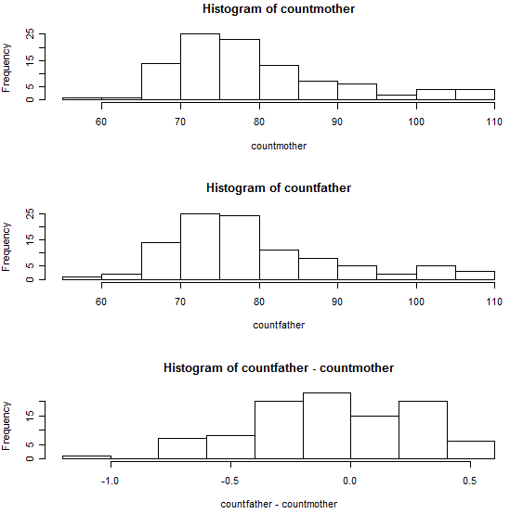
Starting with same mean, using average calculation (mother, father, difference)

Curcio 14
I ran another simulation using the calculation of 1/3*(opposite gender) + 2/3*(same gender) for the offspring formula. I started with the same mean and compiled this simulation. Adding more runs, I found that this taboo led to a much taller population, varying between 5 and 25 inches taller! The gap between males and females widened and the males ended up a little taller than the females, by about two inches. Below is a graph of this scenario:
Starting with same mean, using 1/3(opposite gender) + 2/3(same gender)

My research and simulations were not very conclusive. I found no direct relation between inserting a taboo on height and the overall height of the population. I found that the difference in height between males and females, whether with different means or the same mean, using an offspring height formula more dependent on gender or simply averaging the heights of the parents for the offspring, remained constant. The only time the difference in height changed was when the taboo was placed on the population that started at the same mean and used the
Curcio 15
offspring calculation more dependent on the gender. My simulation was successful in creating stable populations and demonstrated how a restriction placed on height could affect the overall height of the population. Adding more runs led to a more concrete result, and I could easily find the means of each generation and use this to determine what “type” of population it often led to, a taller or shorter one. It also showed just how much variability there was for many of the taboos. Even when the taboos starting at the same mean tended to follow a pattern, there were still many outliers. Starting with the same mean showed the least variability, and the biggest change occurred with the last taboo, starting at the same mean, and using the offspring calculation that was more dependent on gender. Overall, height fluctuated no matter what the taboo, as it was clearly shown in the graphs of the mean heights of men and women. Here is a table of all of my findings:
Summary Table of Taboos
Taboo | Assumptions |  |  | Results
 | Mean |  | Offspring  Calculation | Mean |  | Difference  between M&F
 | M | F |  | M | F
Male taller than female | 69 | 64 | S: Average + 2.5  D: Average – 2.5 | increase & decreased |  | Remained constant
Male taller than female by 6 inches | 69 | 64 | S: Average + 2.5  D: Average – 2.5 | increase & decreased |  | Remained constant
Male taller than female: more generations | 69 | 64 | S: Average + 2.5  D: Average – 2.5 | increase & decreased |  | Remained constant
Male taller than female: more runs | 69 | 64 | S: Average + 2.5  D: Average – 2.5 | Stayed same & decreased |  | Remained constant
Cap on male height (7 ft) | 69 | 64 | S: Average + 2.5  D: Average – 2.5 | increase & decreased |  | Remained constant
Female taller than male: more runs | 69 | 64 | S: Average + 2.5  D: Average – 2.5 | Decreased |  | Remained constant
Male taller than female | 65 | 65 | S: Average  D: Average | Increased by 5 inches |  | Remained constant
Male taller than female | 65 | 65 | S:1/3(F) + 2/3(M)  D:1/3(M) +2/3(F) | Increased by 5-25 inches |  | Males taller by about 2 inches
Curcio 16
Works Cited
Height Chart of Men and Women in Different Countries. Disabled World, 13 Oct. 2008. Web. 11
Mar. 2011. <http://www.disabled-world.com/artman/publish/height-chart.shtml>.
Kettani, Houssain. "2010 World Muslim Population." (2010). Hawaii International Conference
on Arts and Humanities. Web. 10 Mar. 2011.
<http://www.pupr.edu/hkettani/papers/HICAH2010.pdf>.
McDowell MA, Cryar CD, Hirsch R, Ogden CL., Anthropometric reference data for children
and adults: U.S. population, 1999-2002. Advance data from vital and health statistics; no
361. Hyattsville, MD: National Center for Health Statistics. 2005.
Patt, Rhonda. "Predicting a Child's Height | MomsCharlotte.com." Carolina News Panthers
Bobcats Sports Banking | CharlotteObserver.com. The Charlotte Observer. Web. 10 Mar.
2011. <http://www.charlotteobserver.com/2010/11/15/1882343/predicting-a-childs
height.html>.
Simon, Steve. "What Is a Normal Distribution?" 2012. Web. 15 Mar. 2011. <http:/
www.childrensmercy.org/stats/definitions/norm_dist.htm>.
Sokal-Gutierrez, Karen. "Predicting a Child’s Height." Web. 13 Mar. 2011. <http://www.fisher
price.com/fp.aspx?st=665>.
Stapleton, James H. Models for Probability and Statistical Inference: Theory and Applications.
Hoboken, NJ: Wiley-Interscience, 2008. Print.

